http://www.vipabc.com/aspx/portal#

中文 | 英文翻譯
TutorGroup获启明创投注资1500万美元加速拓展中国市场 | TutorGroup began to accelerate expansion into the Chinese market after receiving a US$15 million investment from QiMing Venture Corporation.
舊版VIPABC | Old Version
在線教學說明  免費諮詢  註冊會員  會員登錄  高效學習環境  個性化學習  移動學習  免費熱門講堂  用戶見證  學習專區  企業培訓  (註：此行為Menu選單，能擺放的字數有限，因此翻譯不能太長。如下圖紅色框框所示)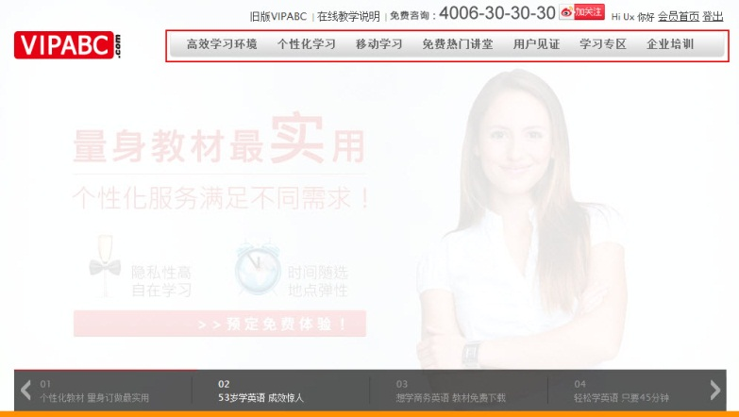 | Learning Guide  Free  Registration  Member Login  Effective  Customized  Mobile  Free Sessions  Client Testimonials  For Learners  Corp. Training
在線客服立即諮詢  免費語言程度分析  體驗最有效率的英文學習方式  請輸入您的姓名  請輸入電子郵箱  請選擇  中國  其他  請輸入移動電話  從何處得知  英語入口網  網易163有道  微博/社交  谷歌/Google  報刊雜誌  電視/廣播  百度  短信/電子報  北京地鐵  朋友介紹  搜狐/Soho  其他  立即預約  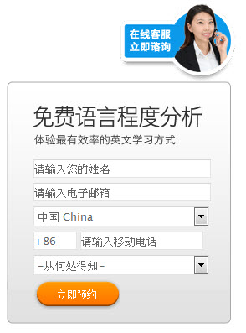 | Online Service  Free language-level analysis  Experience the most efficient method of learning English  Name  E-mail  Please choose  China  Other  Mobile phone number  Where did you hear about us?  English Portal  163 Youdao  Weibo  Google  Newspapers / magazines  TV / Radio  Baidu  SMS / newsletter  Beijing Subway  Friends  Sohu / Soho  Other  Register NOW  Online Customer Service  Free Trial Session Registration  Your Name  Your Email Account  China  Mobile Phone  Indicate how you heard about VIPABC  Register NOW
(廣告01)  個性化教材量身訂做最實用  量身教材最實用個性化服務滿足不同需求！  隱私性高自在學習  時間隨選地點彈性  預定免費體驗  (廣告02)  53歲學英語成效驚人  五十三歲學英語成效驚人  沒請家教，沒上培訓班  只要選對方法，英語一樣呱呱叫！  秘訣公開 GO!  (廣告03)  想學商務英語教材免費下載  輕鬆一點立即下載賺走商務英語教材！  21世紀，你還沒體驗過在線學習的魅力嗎？  還擠在培訓班枯燥，死板的內容嗎？  VIPABC精選最適合上班族的商務英語教材，  更結合職業，興趣，程度，量身訂制課題，  讓你免費下載立即學，英語提升最easy！  馬上變身職場紅人！  (廣告04)  輕鬆學英語只要45分鐘  每天只要45分鐘，  學英語真輕鬆！  告別定時定點，不再出門學英語  免費英語能力測驗 | (Advertisement 01)  Useful personalized materials  Omni directional learning material  Private learning space  Learn anytime, anywhere  Experience a free session  (Ad. 2)  An amazing result of learning English at the age of 53  No tutor, no cram school  The right choice makes for perfect English!  Secrets made public- GO!  (Ad. 3)  Business English material free download  Download free Business English material with just one click.  It’s the 21 century! Haven’t you experienced online learning?  Are you still learning boring English from cram schools?  VIPABC offers the most useful business English that matches speaking, listening, reading and writing lesson plans to each learner's specific requirements according to his or her language abilities, interests and professional background. Free download of material facilitates learning.  Gain recognition at your workplace.  (ad.4)  Easy learning English only for 45 minuets  45 minutes everyday  It’s easy to learn English!  No more English classes. Goodbye!  Free English evaluation.
全英语学习环境  在线学习、真人互动  24H学习不打烊  全球外教顾问移动学习  高效學習方式 提升個人競爭力  学习英语最重要就是「环境」与「方法」， VIPABC 为您量身打造最VIP的英语学习法！忘记过去事倍功半的英语学习阴影，与我们直奔最方便、最具成效的『聪明学习法』。  個性化學習滿足全方位需求  「VIP高效学习法」立即开始崭新的英语学习旅程！  精准掌握您的英语水平：外教顾问为您进行「在线语言程度分析」更了解您英语水平，精准掌握您的英语学习方向  最适合您的课程：  透过个性化的「学习爱好设定」包括：兴趣、学习重点、职业，VIPABC独家专利的DCGS系统会为您配备最合适的课程与外教顾问  最有效的英语学习法：「外教顾问真人在线互动教学」课堂中您将充分了解学习内容，专业外教顾问在线与您即时互动，纠正您的口语发音，解读例句和国外常用语法，让您学到地道的英语！  选择 VIPABC ，让您英语沟通无障碍，遇到外国人不再手足无措  聽、說、讀、寫  客戶導向  方便性  效果 | Global Learning Services  24-hour, Online virtual interactive English learning system  Not limited by time zone  Mobile Learning with Consultants  Improve your competitiveness by learning more efficiently.  Environments and methods are the most important things for English learning. VIPABC offers customized ways to learn English! Forget your old, less efficient learning experiences and start using the most effective smart learning methods.  Personalized learning to meet the needs of everyone.  "VIP efficient learning method" immediately begins a new English-learning journey!  Accurate evaluation of your English level:  "Online Level Placement Analysis Test" by native consultants helps you to understand your level of English and precise directions of your English learning.  Best Courses for you:  Through personalized "Learning Preferences" including interests, learning focus, and occupations, VIPABC’s patented DCGS system provides you with the most appropriate sessions and native consultants.  The most effective method of learning English: live online interactive teaching with native consultants. In our sessions, you will fully understand the learning material and interact with professional native consultants online, who can correct your pronunciation, explain sentences and common expressions to learn how native speakers use English.  Choose VIPABC, and you will no longer have difficulty talking to foreigners.  Listening, Speaking, Reading, Writing  Customer-oriented Results  Convenient  Effective
最精確評級最舒適英語環境  听 / 说 / 读 / 写细分12等级  VIPABC在线英语分析针对个人英语问题深入了解，依照听、说、读、写不同能力细分为十二个等级，专业外教顾问在您学习过程中，精确为您的英语水平把关，让您可以循序渐进提高英语口语、英语听力能力。  美国大学评量方式评估升级  国内英语培训机构与学习系统大都以测验模式作为英语水平升级的依据，而VIPABC 则采用美国优质大学的评量方式，从学习报告、评估、联机操作、效益稽核、测验评量等结合数字专业外教顾问建议并予以评估升级，不受限制测验学习能力，让您真正感受说一口流利英语的成就感。  專業分級  指導學習  模仿學習 | The most precise and the most comfortable English learning environment.  12 levels of Listening/ speaking/ reading/ writing  VIPABC online language evaluations match speaking, listening, reading and writing lesson plans to each learner's specific requirements. Our professional consultants can help you improve your English listening and speaking abilities.  American Universities Evaluation Upgrade System  English training institutions in English speaking nations mostly adopt the exam model as the basis of English level. However, VIPABC adopts the evaluation system from the best U.S universities; according to study reports, assessments, online operation, audits and evaluation from professional foreign consultants. You will feel relaxed in the unrestrained learning environment, and speak fluent English.  Professional level learning.  Learning by Direction  Learning by Imitation
逐步引導學習效果進步看得見  学习追踪系统精确掌握英语学习成效  深怕自己在英语学习过程中无法检视目前成果吗?VIPABC 特别研发学习追踪系统（LMS），针对每一位学习者所学过的教材以及外教顾问指导的过程，留下详细纪录，完整追踪您的英语学习成效  无限复习成效倍增  您不需要一边抄笔记，一边忙着听外教顾问上课，VIPABC 为您全程同步视频上课实况，让您专心听、说英语，还可以无限次复习教材，有效提升自己的英语水平，学习效果倍增，就像置身国外与外籍人士面对面自然开口说英语。 | The effects of learning are apparent through gradual learning.  The effect of English learning can be precisely traced by learning tracking system.  Are you afraid you cannot view your current progress in the process of learning English? VIPABC invented a Learning Management System (LMS), on which materials and the whole process of the sessions of each learner can be traced in detail to facilitate of your learning.  Unlimited Review  You do not have to take notes in class. VIPABC provides you with synchronized video sessions, allowing you to concentrate on listening and speaking English. You can review materials to effectively improve your English as if you were talking to foreigners face- to-face.
告別啞巴英語口語溝通超流利  VIPABC耗时三年研发在线、真人、同步视频英语学习系统，突破传统英语教学窠臼，提供学习者最具方便性的英语学习平台，打破传统英语培训班教学的时间空间限制，您可以自由安排学习计划，任何时间、任何地点皆可在线学习，在全英语学习环境中，与来自全球千位以上专业外教顾问互动咨询，有效提高英语学习效率，降低学习成本，提升英语竞争力。  1对1 英语家教  您可以获得外教顾问百分之百的逐句指导，您甚至能自行提供上课教材（如：工作需要进行的英文简报档案），让顾问针对您的特殊需求，提供完整协助。  1-4人小班英语会话  您将与英语水平相仿的其他客户一同学习英语，您能从他人的发言中，学习到您较少用的单词，听见不同的观点。透过4人以下的小班课程、深具教学经验的外教顾问引导，您的开口权益将不受影响。  主题式英语大会堂  您不只学得英语的「知识」，更通过英语增长「见识」。大会堂的主题多为深具新闻话题、富有启发与趣味的主题，在外教顾问由浅入深的引领下，您可在最短时间内，获得该主题最全面、最实用的英语内容。 | Farewell poor English, hello fluent English!  VIPABC spent three years using the online virtual interactive English learning system. It gives students the most convenient learning platform. It also breaks the traditional, stereotypical learning limitation, and allows learners to set their own learning schedule through online reservations. You can truly learn English anytime and anywhere, interact live with hundreds of native speaker consultants in an English learning environment. The virtual online classroom can increase individual and corporate study effectiveness, decrease study costs, and enhance competitive advantage and learning quality.  1 on 1 English tutor  You will get 100% guidance from foreign consultants; we can even offer a lesson with your own material (For example, an English presentation from work). The consultant can assist you completely according to your need.  Group English conversation class of 1-4 students.  You and other clients from the same level will share a session, and learn from each other. It will not affect your talking right in the group session.  Topic English Special Session  You are not just learning the language, but also learning general knowledge in English. Special session topics are mostly about current events, and all are very interesting and inspiring. You will learn the most useful English in the shortest time.
隨時隨地全世界都是教室！  VIPABC 全面支持移动学习，VIPABC On The Go提供24小时订位/在线英语学习  「移動詞匯通」每日精選5個單詞  「詞匯快手」玩遊戲輕鬆提升英語單詞能力  「英語學習報」了解各國時事脈動  「英語急救站」兼具趣味與實用的英語學習短片  最熱門話題精彩層出不窮  全球专业外教顾问在线提供包罗万象的主题式英语，精彩咨询内容，名额有限，马上报名  2013/09/12 20:30星期四  如何让老板自动帮你加薪  全英语发音  适合初级或想学英语的您  職場英語系列  如何讓老闆自動幫你加薪！  立即預約 | Classrooms all over the world, anytime, anywhere!  VIPABC fully supports mobile learning. VIPABC On the Go offers 24-hour reservation / online English learning.  Mobile vocab learning: five selected new words daily  Vocab: boost your vocab by playing games  Epaper: keep abreast of current events  Videos: Amusing useful videos for English learning  Plenty of the hottest topics  Register NOW for sessions by professional native consultants around the world with a diverse range of topics.  2013/09/12 20:30 Thu.  How to Get a raise  English Pronunciation  For basic level or those who want to learn English  Business Series  How to Get a Raise  Book NOW
全球用戶都有成功故事  您，就是下一位  感谢每位客户对我们的支持及肯定，您的进步与成功是对我们最大的鼓励 VIPABC坚持给您高质量及便利有效的英语学习方式，数万位职场菁英的共同选择，诚挚的推荐给您！  跨越口說挑戰前進倫敦夢想學院！  電影工作者-袁之翔真摯推薦  世界知名品牌Adidas 精益諮詢師-耿海辰  上海歐力特投資管理有限公司總經理-康徐夫婦  電腦公司總經理楊銀平  高露潔三笑銷售高管--閆江萍  上海諾德科商貿有限公司管道經理--董傑 | Every client has their own success story  You can be the next!  Thank you for all the support and trust. Your improvement and success is our best encouragement. VIPABC will always give you the best quality and the most convenient way to learn English. Highly recommended by thousands of elites!  Recommended by Filmmaker Yuan Zhi-Xiang, who was admitted into The London School of Economics and Political Science.  Consultant of World-renowned brand Adidas - Geng Hai-Chen  General Manager of Investment Management Co., Ltd.- KANG XU couple  General Manager of Computer Company – Yang Yin-Ping  Colgate Sanxiao Sales Executives - Yan Jiang-Ping  Channel Manager of KRONOTEX (SHANGHAI) PTE.LTD - Dong Jie
訂閱成功的關鍵  VIPABC 特别为您提供英语学习专区，让您轻松加强英语能力  每日一句  每天的英文營養品 隨時補充英語實力  英語學習報  英語急救站  訂閱英語報  請輸入您的郵箱 立即訂閱 | The Keys to Success  VIPABC provides you with English learning to improve your English.  Phrase of the Day  Daily help to improve your English  E-paper  Videos of First-aid Station  Subscribe to e-paper  Your email  Subscribe NOW
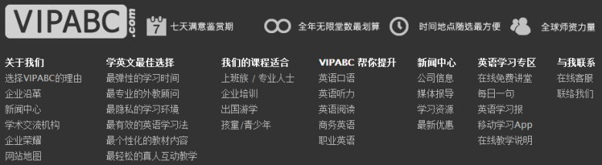  (此部分要考慮字數問題)  全年無限堂數最划算  時間地點隨選最方便  全球師資力量  關於我們  選擇VIPABC的理由  企業沿革  新聞中心  學術交流機構  企業榮耀  網站地圖  學英文最佳選擇  最彈性的學習時間  最專業的外教顧問  最隱私的學習環境  最有效的英語學習法  最個性化的教材內容  最輕鬆的真人互動教學  我們的課程適合  上班族 / 專業人士  企業培訓  出國遊學  孩童 / 青少年  VIPABC 幫你提升  英語口語  英語聽力  英語閱讀  商務英語  職業英語  新聞中心  公司信息  媒體報導  學習資源  最新優惠  英語學習專區  在線免費講堂  每日一句  英語學習報  在線教學說明  与我联系  在线客服  联络我们 | Economical Unlimited Sessions  Anytime, Anywhere  Global Teaching Resources  About us  Reasons to choose VIPABC  History of Enterprise  News  Academic Affiliates  Honors of Company  Website Map  Best Choice  Flexible Schedule  Professional Native Consultants  Private Learning  Most Effective Learning  Customized Materials  Live Interaction  Our sessions are for:  Businesspeople / Professionals  Corporate Training  Customized Materials  Children/Teenagers  VIPABC helps your:  Speaking  Listening  Reading  Business English  Workplace English  News  Messages  Media  Learning Resources  Discount  For Learners  Online Free Sessions  Phrase of the Day  Epaper  Online Instructions  Contact us  Online Service  Contact us
关于VIPABC  隐私保护  安全条款  服务条款  诚征英才  企业培训  联络我们  教育许可 : 教职成司函 [ 2011 ] 267 号 |  经营许可证 : 京 ICP 证 090121 号 |  京 ICP 备 11004351 号  VIPABC.com 版權所有 2008-2013 全球最大英語真人外教網 | About VIPABC  Privacy Protection  Terms of Security  Terms of Service  Recruiting  Corporate Training  Contact Us  Education License: Faculty Division Document [2011] No. 267 |  License: Jing ICP Certificate No. 090121 |  Beijing ICP 11004351 No.  VIPABC.com Copyright 2008-2013 the world's largest English Online Learning

